Unit 4 Assignment Instructions – CIS164 
For the Unit 4 Assignment we will be working with functions. Functions are used within programming languages, such as Python, to help minimize redundant code and to also allow for re-usable code.
Please make sure to fully read each question to ensure that you answer each question per the requirement. Also, please ensure that all responses are in complete sentences, free of spelling and grammatical errors.
*Unit 4 Grading Rubric (45 Points):
Assignment Requirements | Maximum Points | Points Earned
1. Define Functions | 0-5 Points
2. Beginning Functions | 0-10 Points
3. Intermediate Functions 1 | 0-15 Points
3. Intermediate Functions 2 | 0-15 Points
Points Deducted for Spelling or Grammatical Errors
Total (Sum of All Points)
*Directions for Submitting Your Assignment:
Complete your assignment ensuring all questions are answered based on the assignment requirements. When the Unit 4 assignment is complete, please save your file in the following format, “Lastname-Unit#.doc” (Example: Smith-Unit4.doc). You may also utilize a Word Processing software such as LibreOffice for assignment completion. In this case the assignment may be saved in .odt format, (Example: Smith-Unit4.odt). Then when ready submit your file to the “CIS 164 – Unit 4 Submit Assignment” activity for grading.

1. Define Functions
- Define in your own words what functions are used for.

Functions (or methods as my C# background urges me to call them) are intended for re-usability. Simply put, functions are most effective when used to recall code that you (or somebody else) have already written, without having to remember the specific details of every function you use.

- Provide an idea of when you feel that a function in Python would be beneficial within a potential script or program you perhaps would like to write in the future.

I use functions so much now it’s hard to come up with just one. I would say using a function to handle the attack behavior of an enemy AI in a video game (perhaps with pycharm?) would be an option. Really, the best use of that function would be to be as generic as possible and be used for the player as well, but it just depends on how the classes and name spaces are setup and the game itself.

2. Using Functions
- Start the PyCharm IDE. Select “File->New Project” on the next screen. Under “Location” change the word “untitled” to “Unit4”. Then click the “Create” button.

- Highlight your project “Unit4” then right click. When you right click a menu will appear, from this menu select New->Python File. Then a dialog box will appear, in the “Name” field of the dialog box type “UsingFunctions.py”.

- Within your UsingFunctions.py file, create a function that takes input from a user from inside your function that asks what a person’s name is. Then when a user inputs their name, take the value for their name and print out the following:

“Hello {user’s name here} I hope you are having a great day!”

- For your script, you will need to provide a screenshot showing your completed script, you will also need to submit it in a text file, along with this document.

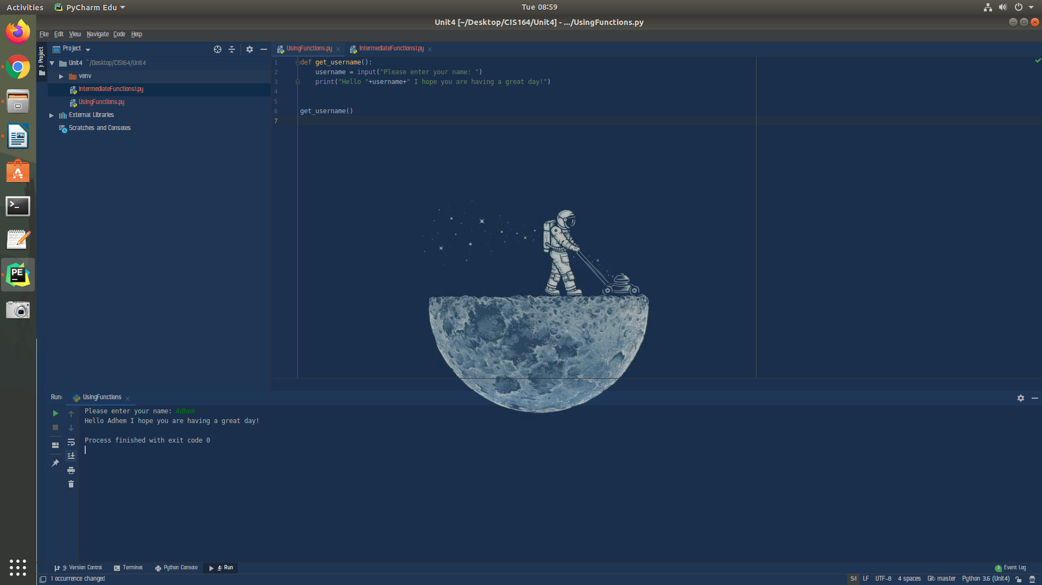

3. Intermediate Functions 1
- Highlight your project “Unit4” then right click. When you right click a menu will appear, from this menu select New->Python File. Then a dialog box will appear, in the “Name” field of the dialog box type “IntermediateFunctions1.py”.

- Within your IntermediateFunctions1.py file, create a function that takes in the value for 2 different numbers as parameters. The numbers will not be set within your function; they will be passed as parameters to your function! Then inside your function set the output of the addition, subtraction, multiplication, and division of the 2 numbers passed as parameters to the function to return when the script is run.

**Note: You will not be including a “print” statement inside your function, you would use the “return” statement**.

- For your script, you will need to provide a screenshot showing your completed script, you will also need to submit it in a text file, along with this document.

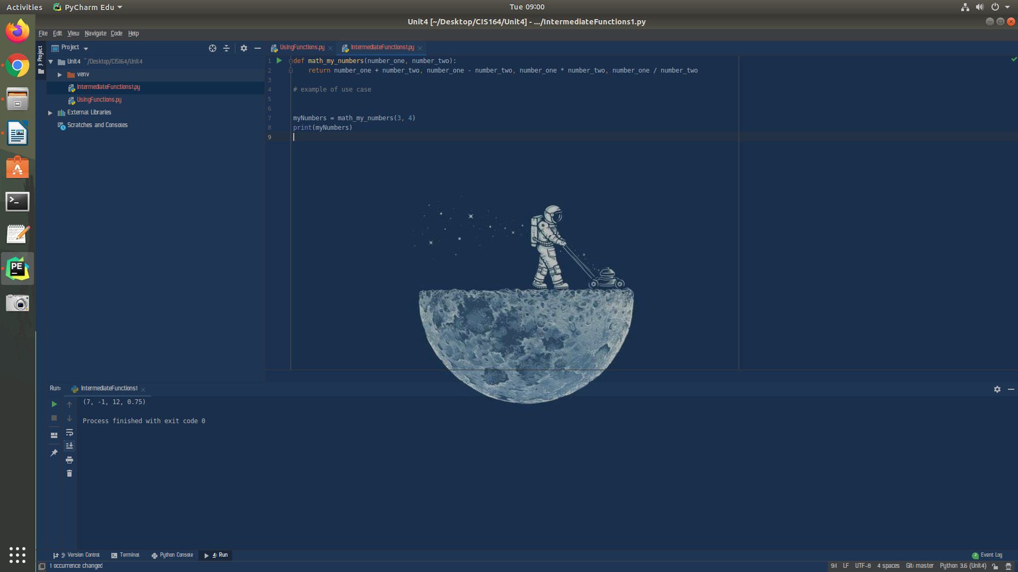

4. Intermediate Functions 2
- Highlight your project “Unit4” then right click. When you right click a menu will appear, from this menu select New->Python File. Then a dialog box will appear, in the “Name” field of the dialog box type “IntermediateFunctions2.py”.

- Within your IntermediateFunctions2.py file, create a function that takes in the value for 2 parameters, a name of a user and also today’s date. The values will not be created within your function, they will be passed as parameters to your function to make it reusable for different names and dates! For the date value, you can simply set the day of the week to a value such as Monday, Tuesday, Wednesday, etc…. you can set this yourself, or if you are feeling courageous you can learn about and import the datetime Python library to do this for you. When your script is run, your function should return the following:

“Hello {user’s name here} I hope you are having a great {today’s date here}!”

**Note: You will not be including a “print” statement inside your function, you would use the “return” statement**.

- For your script, you will need to provide a screenshot showing your completed script, you will also need to submit it in a text file, along with this document.

